**EEE 423 GROUP ASSIGNMENT**

**EXPERIMENT TOPIC**

Infra red proximity sensor

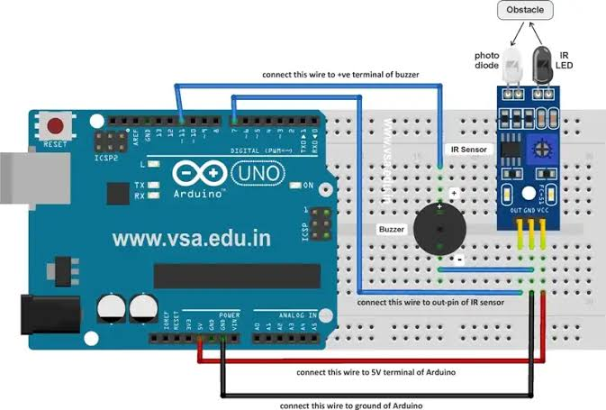

**AIM**

To determine when there is obstruction within a distance

**PROCEDURES**

**1) The 5v pin of the Arduino board was connected to the VCC pin of IR sensor module via the Breadboard.**

**2) The GND pin of Arduino board was connected to the Breadboard and looped to the GND pin of Infrared sensor module.**

**3) The GND line taken from the Arduino board to the Breadboard was looped to the GND pin of the buzzer (Black wire).**

**4) Pin 3 of the Arduino board was allocated to the OUTPUT of the IR sensor module and was connected via the Breadboard.**

**5) Pin 5 of the Arduino board was allocated to the OUTPUT pin of the buzzer and was connected in the Breadboard (Red wire).**

**6) All connections were carefully made, firm, tidy and inspected before connection to the computer system.**

**7) The code was compiled and test-runned for bugs.**

**The compiled code was run using the Arduino IDE**

**Hard ware requirements:**

* Arduino uno board.
* Banana wires.
* Breadboard.
* IR sensor module.
* Buzzer.

**CODE**

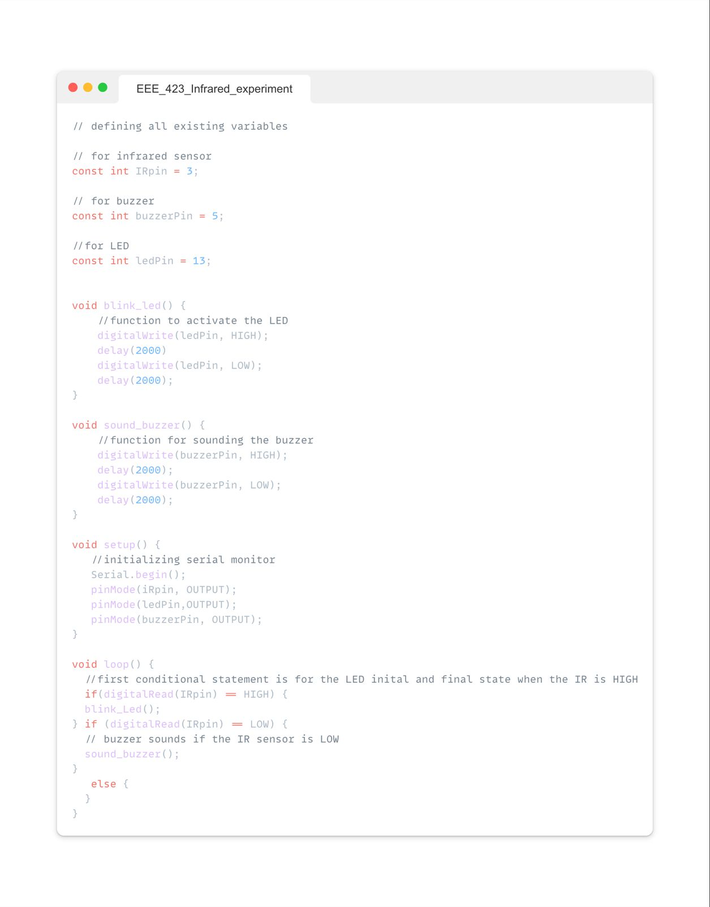

**RESULTS**

The sensor was able to pick up obstructions at am approximate distance of 5cm

**APPLICATIONS**

1. IR sensors are now widely used in motion detectors, which are used in building services to switch on lamps.

2. They are also used in alarm systems to detect unwelcome guests.

3. Since all object have some form of thermal radiation, IR sensors can measure the heat of an object.

4. Smartphones and other mobile devices often use infrared proximity sensors to detect the user’s proximity to the screen, adjusting display brightness and disabling touch input during calls.